PROJECT REPORT

TITLE:
SUPERSTORE SALES, PROFITABILITY, AND CUSTOMER TREND ANALYSIS

NAME: NASIHA M S
BATCH: DA55

INDEX (Table of Contents)
- Title Page ....................................................... 01
- Index .............................................................. 02
- Abstract ......................................................... 03
- Introduction ................................................. 03
- Problem Statement ..................................... 03
- Project Objectives ..................................... 04
- Dataset Description .................................... 04
- Tools and Technologies Used ..................... 04
- Data Cleaning and Preprocessing .............. 05
- Exploratory Data Analysis (EDA) ............. 05
- Data Visualization & Interpretations ....... 05
- Key Findings and Insights ........................ 11
- Recommendations .................................... 11
- Conclusion ................................................ 12
- Limitations and Future Scope ................ 12
- References ................................................ 12
3. ABSTRACT
- This project provides an in-depth analysis of retail sales, profitability, and customer purchasing behaviours using the Sample Superstore dataset.
- The primary purpose is to identify revenue drivers, analyse product category performances, and uncover operational bottlenecks such as heavy discounting leading to financial losses.
- Utilizing Python libraries for data preprocessing, exploratory data analysis (EDA), and advanced visualizations, the study highlights critical business insights.
- New Additions: Recent profitability assessments reveal a critical commercial paradox: high-gross sales categories do not automatically guarantee profitability, as aggressive discounting exceeding 20% to 30% severely erodes margins, leading to heavy financial losses in sub-categories like Tables, Bookcases, and Supplies.

4. INTRODUCTION
- Retail businesses generate massive volumes of transactional data daily. Analysing this data is crucial for understanding market dynamics, optimizing supply chains, and maximizing profitability.
- This project centres on the Sample Superstore dataset to evaluate historical sales, regional demands, and product-level profitability.
- By transforming raw data into actionable intelligence, the project demonstrates how data-driven decision-making can solve commercial challenges.

5. PROBLEM STATEMENT
- Retail enterprises frequently encounter a counter-intuitive phenomenon: increasing gross sales volume does not consistently correlate with positive net profits.
- Uncontrolled discounting policies, uneven regional cost structures, and loss-making product sub-categories can silently erode organizational margins.
- This project addresses the core challenge of identifying operational inefficiencies, detecting loss drivers, and evaluating the true impact of discount thresholds on overall profitability.

6. PROJECT OBJECTIVES
- Execute a robust 10-step data cleaning and preprocessing pipeline to ensure data integrity.
- Perform rigorous Exploratory Data Analysis (EDA) to uncover sales patterns and sstrends.
- Visualize key commercial metrics using statistical and interactive charts.
- Uncover product sub-categories generating net financial losses versus those yielding high profits.
- Analyse the quantitative relationship between discount levels and profitability using scatter plots and correlation matrices.
- Formulate evidence-based business recommendations to optimize pricing strategies and enhance operational ROI.

7. DATASET DESCRIPTION
- Source: Kaggle - Sample Superstore Dataset
- Total Records (Rows): 9,994
- Total Features (Columns): 21 (expanded during feature engineering)
- Key Important Columns:
  - Order Date & Ship Date: Temporal details for trend analysis.
  - Sales: Quantitative metric representing revenue generated.
  - Profit: Quantitative metric representing net financial gain or loss.
  - Discount: Percentage discount applied to transactions.
  - Category & Sub-Category: Product classification fields (updated to remove hyphens).
  - Region: Geographic sales territories (West, East, Central, South).

8. TOOLS AND TECHNOLOGIES USED
- Programming Language: Python (v3.10+)
- Data Manipulation & Analysis: Pandas, NumPy
- Data Visualization: Matplotlib, Seaborn, Plotly Express
- Development Environment: Google Colab / Jupyter Notebook
9. DATA CLEANING AND PREPROCESSING
- Handling Missing Values: Checked the dataset for null values; confirmed zero missing entries.
- Removing Duplicate Records: Scanned for duplicated rows and verified zero duplicates.
- Correcting Data Types: Converted Order Date and Ship Date from object type to datetime64[ns] format. Standardized postal codes to 5-digit strings.
- Identifying & Handling Outliers: Analysed numerical spreads via statistical distribution and box plots, noting legitimate high-value corporate orders and heavy discount losses.
- Checking Invalid Values: Validated that sales, quantities ($≥1$), and discount ranges ($0\text{ to }1$) contained no logical errors.
- Correcting Inconsistencies: Trimmed whitespaces from text columns and renamed columns (e.g., Sub-Category to Sub_Category, Postal Code to Postal_Code) for cleaner coding.
- Feature Engineering: Extracted temporal features (Order Year, Order Month, Order YearMonth, Order Day of Week) and financial metrics (Unit Price = Sales / Quantity, Profit Margin = Profit / Sales).

10. EXPLORATORY DATA ANALYSIS (EDA)
- Classified all variables into qualitative (identifiers/categorical) and quantitative (continuous/discrete) types.
- Computed comprehensive numerical statistics (mean, median, minimum, maximum, standard deviation) for Sales, Profit, Quantity, Discount, Unit Price, and Profit Margin.
- Analyzed categorical frequencies to identify top-performing product sub-categories (e.g., Binders, Paper, Phones) and high-volume regional markets (West and East).

11. DATA VISUALIZATION & INTERPRETATIONS
- Category & Regional Sales Bar Charts: Technology ($836k) and Furniture ($742k) dominate gross sales. (Interpretation: High sales volume does not guarantee profitability).
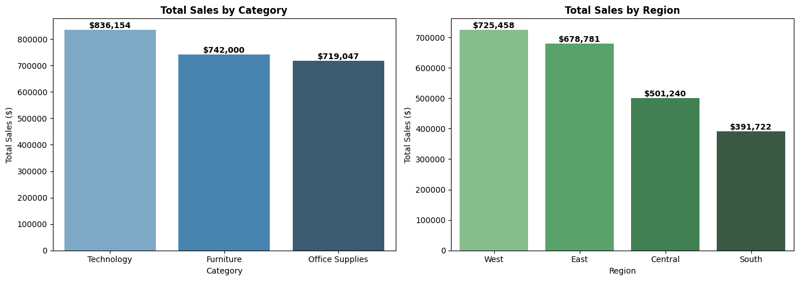
- Monthly Sales Trend Line Chart: Displayed chronological order trends revealing seasonal end-of-year sales spikes.

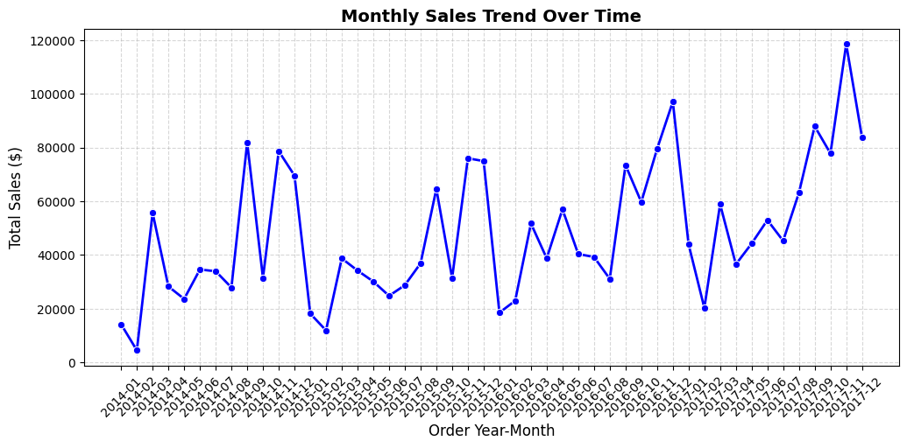

- Sales Distribution Histogram & Box Plots: Highlighted right-skewed transaction frequencies under $500 alongside severe profit loss outliers.
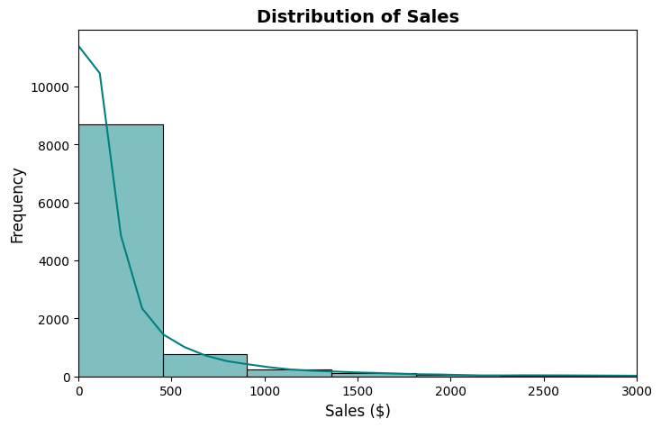
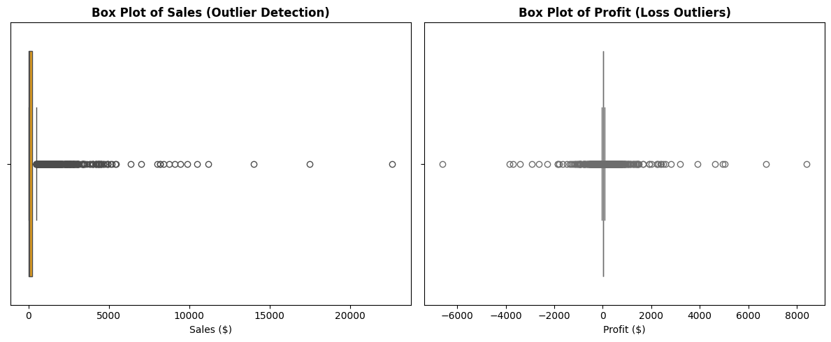

- Sales vs. Profit Scatter Plot: Plotted individual transactions against sales and profit, highlighting that higher sales volume transactions do not always yield positive returns. (Interpretation: A significant cluster of high-sales transactions dips below the zero-profit line, driven entirely by heavy discounting practices)
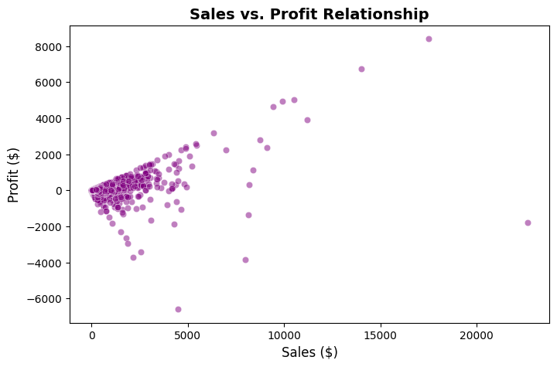

- Interactive Donut Pie Chart (Plotly): Illustrated sales shares (Technology: ~36.4%, Furniture: ~32.3%, Office Supplies: ~31.3%) while noting that revenue share alone does not equate to profit.

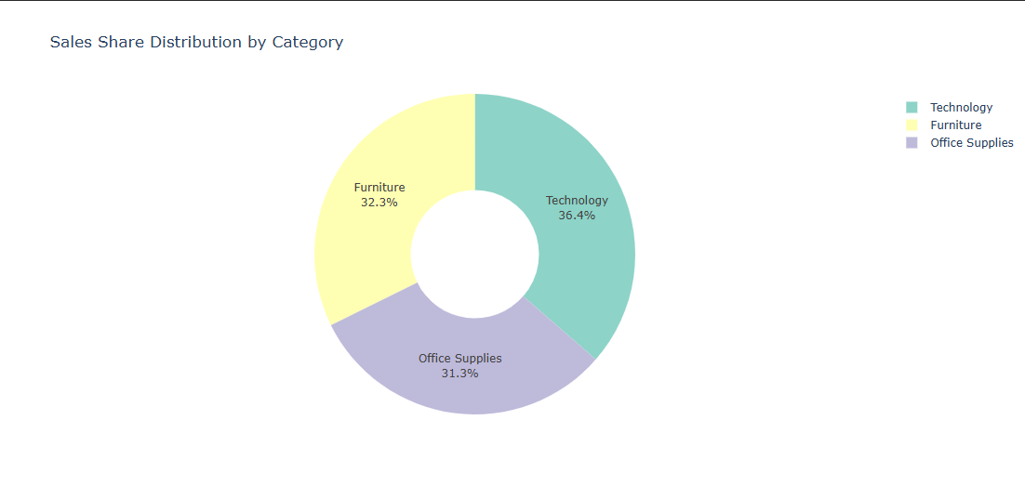

- Correlation Heatmap: Evaluated meaningful numerical features (Sales, Quantity, Discount, Profit, Unit Price, Profit Margin), excluding unnecessary identifiers like Row ID or Postal_Code.

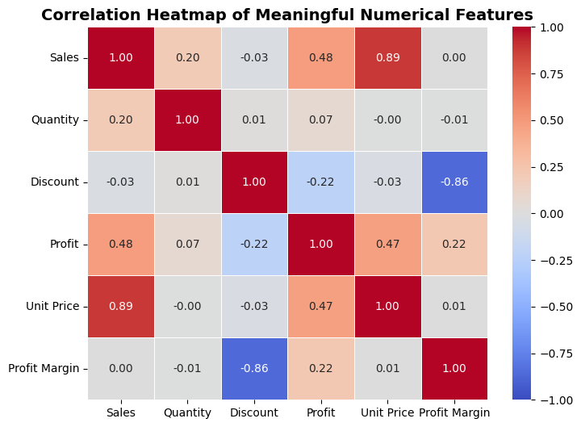

- Profit by Sub-Category Bar Chart: Highlighted that while Copiers, Phones, and Accessories generate stellar profits, sub-categories like Tables, Bookcases, and Supplies suffer heavy net losses below the zero line.
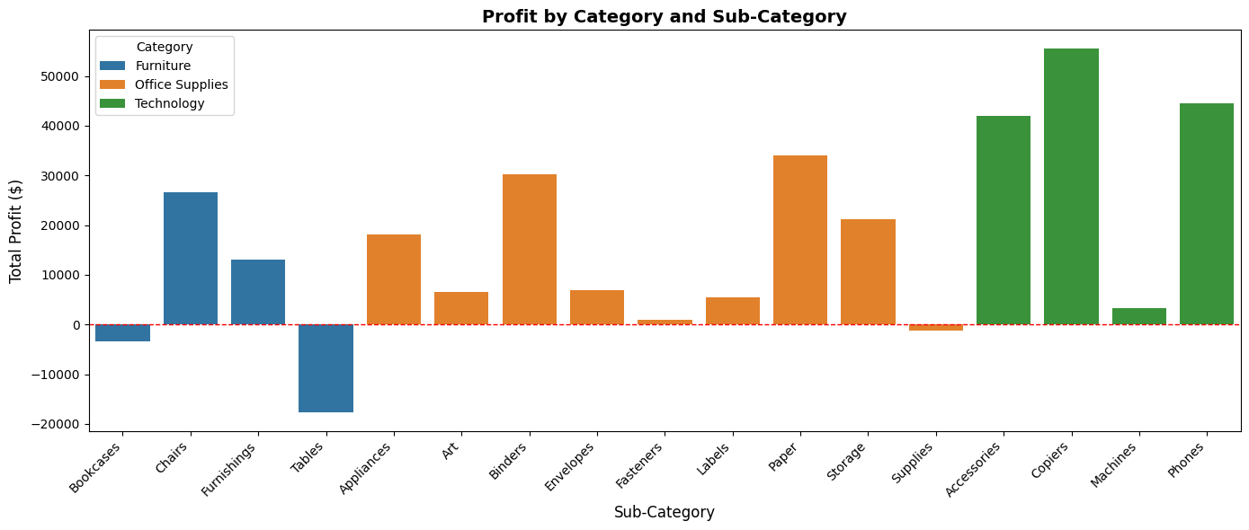

- Discount vs. Profit Scatter Plot: Proved that discounting beyond 20%–30% drives profit sharply below zero into heavy financial loss.
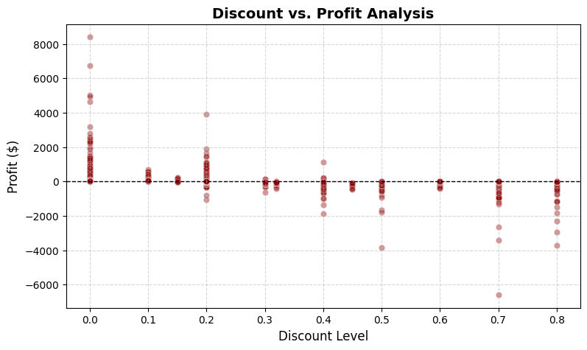

- Regional Profitability Comparison: Demonstrated that the West secures the highest net profit, whereas the Central region lags significantly behind its sales volume due to excessive discounting.
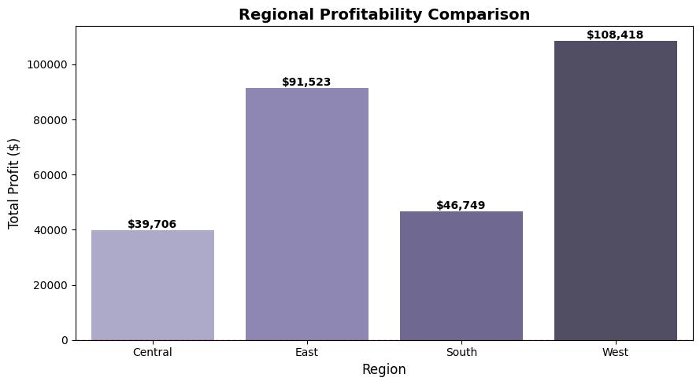

- Top 10 Products by Sales Bar Chart: Identified premium office equipment and Cisco TelePresence systems as top gross revenue drivers.

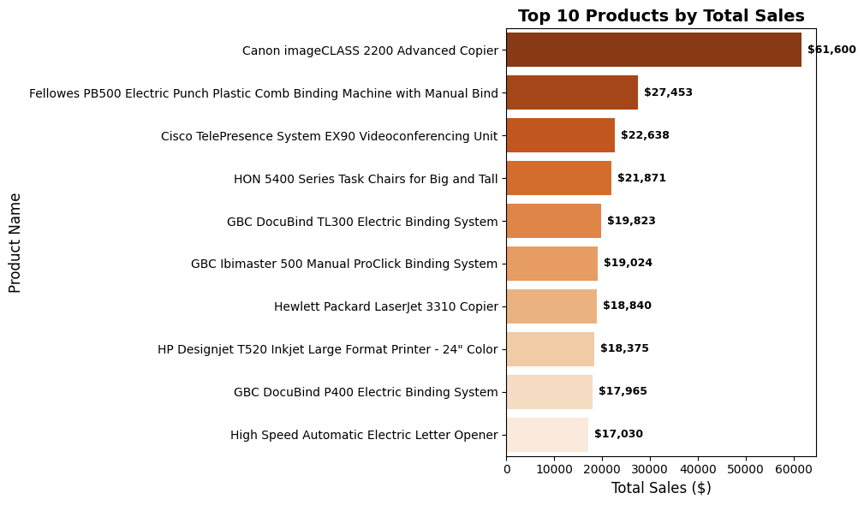

12. KEY FINDINGS AND INSIGHTS
- Category Dominance: Technology and Furniture generate the lion's share of total revenue, acting as primary business growth pillars.
- The Discount Trap (New): Transactions with discounts exceeding 20%–30% consistently result in net financial losses, specifically eroding margins in Tables, Bookcases, and Supplies.
- Regional Inefficiencies (New): The Central region exhibits high sales activity but negative/low profitability compared to the West region, indicating misaligned regional promotional strategies.
- Transaction Skewness: The right-skewed sales distribution indicates that while high-frequency retail orders are smaller, bulk corporate orders drive upper-bound revenue spikes.

13. RECOMMENDATIONS
- Cap Maximum Discounts (New): Restrict high discount percentages (above 20%) on vulnerable sub-categories like Tables, Bookcases, and Supplies to eliminate net-loss transactions.
- Focus on High-Margin Inventories: Allocate greater marketing budgets and stock resources toward top-performing categories like Technology (Copiers and Phones).
- Audit Central Region Pricing (New): Conduct an immediate operational review of discount approval workflows in the Central sales district to align profitability with sales volume.

14. CONCLUSION
- This project successfully evaluated the Sample Superstore dataset through a structured data analytics pipeline.
- By executing robust data cleaning, detailed EDA, and comprehensive visualizations, the analysis fulfilled its objectives.
- The findings demonstrate that strategic shifts in discount management, pricing control, and inventory prioritization can significantly boost enterprise profitability and overall ROI.

15. LIMITATIONS AND FUTURE SCOPE
- Limitations: The dataset lacks customer demographic details (age, income) and external economic factors (inflation, competitor pricing) which could further refine profitability insights.
- Future Scope: Future work can incorporate predictive machine learning models (such as Linear Regression or Time-Series Forecasting) to predict future sales trends and customer churn.

16. REFERENCES
- Dataset Source: Kaggle - Sample Superstore Dataset
- Documentation & Libraries: Python Official Documentation, Pandas, Seaborn, and Plotly Libraries.

